1. Provide a screenshot to show the GenerateFilesWithDask.py file in the Activity_22.2 folder.

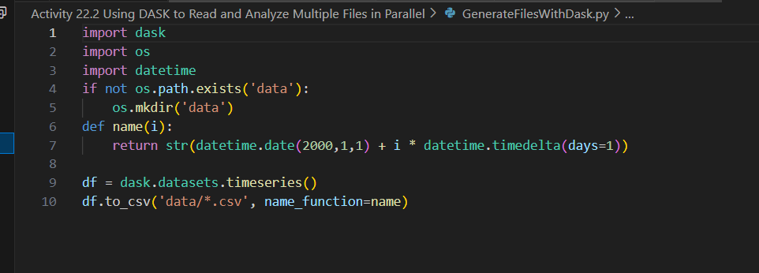

1. Provide a screenshot to show that the /data folder has been successfully created.

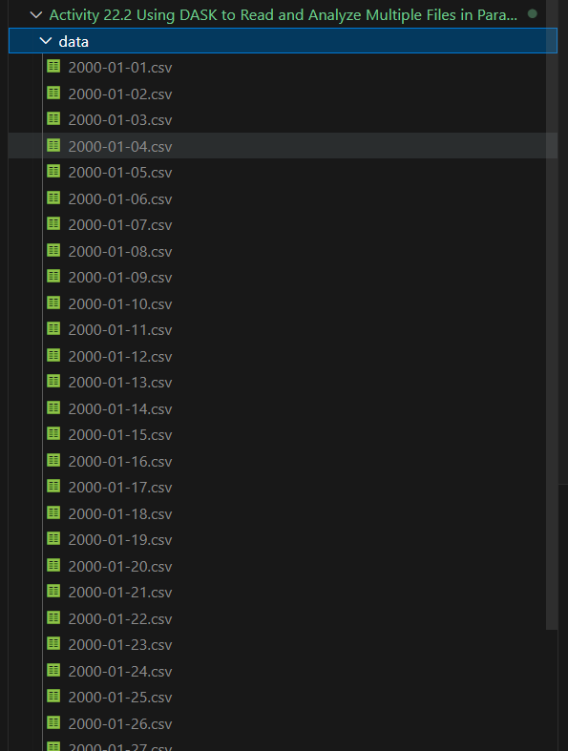

1. Provide a screenshot to show the Activity22-2.py file is in the Activity_22.2 folder.

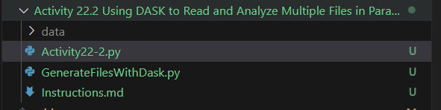

1. Provide a screenshot to show that the correct DASK *libraries* have been imported into the Activity22-2.py file.

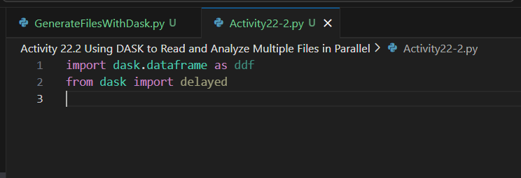

1. Provide a screenshot to show the head of the DASK *dataframe* and display that the DASK *dataframe* correctly displays the first five rows.

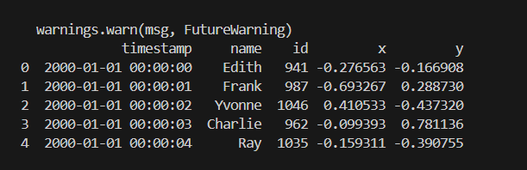

1. Provide a screenshot of your Terminal window to show the output after you have *printed* the computed mean of the *dataframe*.

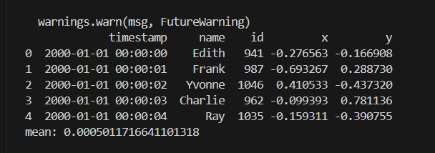

1. Provide a screenshot of your Terminal window to show the number of columns in the *dataframe*.

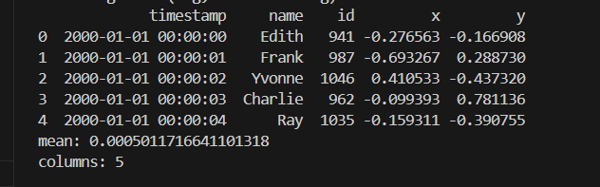

1. Provide a screenshot of your Terminal window to show the number of rows in the *dataframe*.

